Manufacturing Tool V2 (MFGTool2) Factory Operation Manual

Contents

Overview 2

PC Requirement 2

Operation Flow 3

Operation Notes 3

# Overview

The document is prepared for factory operators and describes how to correctly use the manufacturing tool.

# PC Requirement

* **CPU**: Intel E3400 or higher, Frequency: 2GHz+
* **Memory**: 4GB+
* **OS**: Windows XP/Windows 7 version.
* **USB2.0 root hub is a must, NO USB 1.1 root hub is allowed.**

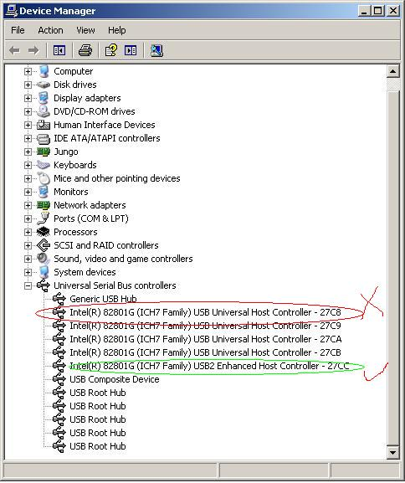

* **External USB hub is allowed with restrictions below:**
  + **Must use independent power supply**
  + **Must pass the compliance test of USB org, Belkin USB hub is recommended.**
  + **No more than 4 devices are allowed to be connected to USB hub.**

# Operation Flow

Please refer to “Manufacturing Tool V2 Quick Start Guide.”

# Operation Notes

* The file "mksdcard.sh" is used to create partitions on the storage medium for Linux. The size of this partition is defined by "BOOT_ROM_SIZE". In this file,it should be modified manually if necessary.

* The file "mksdcard-android.sh" is used to create partitions on the storage medium for Android. Eight partitions will be created. The sizes of these partitions are defined by "BOOT_ROM_SIZE", "SYSTEM_ROM_SIZE", and “DATA_SIZE", and so on. They should be modified manually if necessary.

* For the Android related operation, before you start it, please get the latest Android images and put them under "profiles/CHIP_PROFILE/OS Firmware/files/android". For Freescale internal users, you can get these from <ftp://10.192.224.88/android_nightly/>.



